1. **Google search** python script

**Assignment1:** Create a python script called googlesearch that provides a command line utility to perform google search. It gives you the top links (search results) of whatever you want to search on google.



*#Google search python scrit  
#created by 'Ankit Nema'***import** webbrowser  
  
new=2;  
  
url=**'http://www.google.com/#q='**;  
ip=input(**"Query for search : "**)  
webbrowser.open(url+ip,new=new);  
print(url)

2. location search for **IBM Pune**

**Assignment 2.** Create a script called location that return the location parameters of any location you want



*'''  
#created for location search python script  
#created by 'Ankit Nema'  
here I have installed module 'requests' in my project folder  
python -m pip install requests  
then I have added json module  
'''***import** sys  
**import** webbrowser  
**import** json  
**import** requests  
  
URL = **"http://maps.googleapis.com/maps/api/geocode/json"**location = **"IBM, Pune"**parameters = {**'address'**:location}  
  
r = requests.get(url = URL, params = parameters)  
  
content = r.json()  
  
latitude = content[**'results'**][0][**'geometry'**][**'location'**][**'lat'**]  
longitude = content[**'results'**][0][**'geometry'**][**'location'**][**'lng'**]  
formatted_address = content[**'results'**][0][**'formatted_address'**]  
print(**"Latitude:%s\nLongitude:%s\nFormatted Address:%s"**%(latitude, longitude,formatted_address))

**Result:**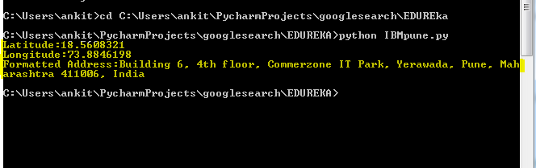

**3. weather forecast**

**Assignment3.** Create a script called weather that return the environmental parameters (temperature (min, max), windspeed, humidity, cloud, pressure, sunrise and sunset) of any location you want; after passing arguments (like user api and city id).



after execution: for weather of **Pune**

**my API id:** a2f49fe3892d3a13b3e2e71b52f7e11a

**city ID : 1259229**

**To install beautifulsoup 4 :**

**/python -m pip install bs4**

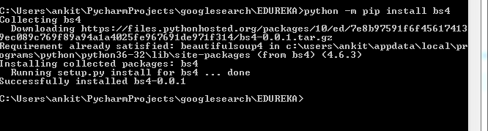

**RESULT**

